**Sample 2**

|  |  |
| --- | --- |
| 1. | The difference of two numbers is 1365. On dividing the larger number by the smaller, we get 6 as quotient and the 15 as remainder. What is the smaller number? |

|  |  |  |  |
| --- | --- | --- | --- |
| [**A.**](javascript:%20void%200;) | 240 | [**B.**](javascript:%20void%200;) | 270 |
| [**C.**](javascript:%20void%200;) | 295 | [**D.**](javascript:%20void%200;) | 360 |

2. How many of the following numbers are divisible by 3 but not by 9?

2133, 2343, 3474, 4131, 5286, 5340, 6336, 7347, 8115, 9276

|  |  |  |  |
| --- | --- | --- | --- |
| [**A.**](javascript:%20void%200;) | 6 | [**B.**](javascript:%20void%200;) | 7 |
| [**C.**](javascript:%20void%200;) | 5 | [**D.**](javascript:%20void%200;) | None of these |

|  |
| --- |
| 3. If the product 4864 x 9 P 2 is divisible by 12, then the value of P is: |
| |  |  |  |  | | --- | --- | --- | --- | | [**A.**](javascript:%20void%200;) | 2 | [**B.**](javascript:%20void%200;) | 5 | | [**C.**](javascript:%20void%200;) | 7 Hours | [**D.**](javascript:%20void%200;) | None of these | |

|  |
| --- |
| 4. A man can cover a distance in 1hr 24min by covering 2/3 of the distance at 4 km/h and the rest at 5km/h. The total distance is: |
| |  |  |  |  | | --- | --- | --- | --- | | [A.](javascript:%20void%200;) | 5 km | [B.](javascript:%20void%200;) | 6 km | | [C.](javascript:%20void%200;) | 7 km | [D.](javascript:%20void%200;) | 8 km | |

5. The ratio between the speeds of two trains is 7: 8. If the second train runs 440 kms in 4 hours, then the speed of the first train is:

A. 47.4 km/hr B. 57.19 km/hr C. 68.13 km/hr D. 96.25 km/hr

6. If “LBAEHC” is the code for “BLEACH” , then which of the following is coded “NBOLZKMH” ?

|  |  |  |  |
| --- | --- | --- | --- |
| [**A.**](javascript:%20void%200;) | BNLOKZHM | [**B.**](javascript:%20void%200;) | MANKYJLG |
| [**C.**](javascript:%20void%200;) | LOBNHMKZ | [**D.**](javascript:%20void%200;) | OBNKZLHM |

7. Pointing to a photograph, a man said, "I have no brother or sister, but that man’s father is my father’s son." Whose photograph was it?

|  |  |  |  |
| --- | --- | --- | --- |
| [**A.**](javascript:%20void%200;) | His own | [**B.**](javascript:%20void%200;) | His nephew’s |
| [**C.**](javascript:%20void%200;) | His father’s | [**D.**](javascript:%20void%200;) | His son’s |

**8.** A family consists of six members P, Q, R, X, Y and Z. Q is the son of K but K is not mother of Q. P and K are a married couple. Y is the brother of K. X is the daughter of P. Z is the brother of P. How many children does P have? http://books.tamilcube.com/image/blank.gif

|  |  |  |  |
| --- | --- | --- | --- |
| [**A.**](javascript:%20void%200;) | 1 | [**B.**](javascript:%20void%200;) | 2 |
| [**C.**](javascript:%20void%200;) | 3 | [**D.**](javascript:%20void%200;) | 4 |

|  |  |  |  |  |  |  |  |  |
| --- | --- | --- | --- | --- | --- | --- | --- | --- |
| **9.** Based on the following statements, which is the correct conclusion drawn.  All mangoes are golden in color. No golden-colored things are cheap. http://books.tamilcube.com/image/blank.gif   1. All mangoes are cheap. 2. Golden-colored mangoes are not cheap.  |  |  |  |  | | --- | --- | --- | --- | | [**A.**](javascript:%20void%200;) | Only conclusion 1 follows | [**B.**](javascript:%20void%200;) | Only conclusion 2 follows | | [**C.**](javascript:%20void%200;) | Either I or II follows | [**D.**](javascript:%20void%200;) | Neither I nor II follows | |

10. Look at this series: 53, 53, 40, 40, 27, 27, ... What number should come next?http://books.tamilcube.com/image/blank.gif

|  |  |  |  |
| --- | --- | --- | --- |
| [**A.**](javascript:%20void%200;) | 12 | [**B.**](javascript:%20void%200;) | 14 |
| [**C.**](javascript:%20void%200;) | 27 | [**D.**](javascript:%20void%200;) | 53 |

11. Which figure completes the series? http://books.tamilcube.com/image/blank.gif

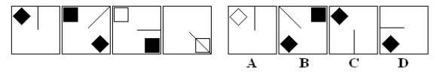

12. Which figure completes the series? http://books.tamilcube.com/image/blank.gif

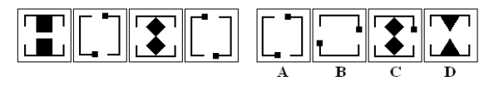

13. Which figure belongs in neither group?

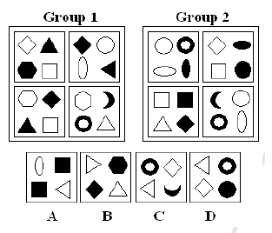

14. Which figure is next in the series?http://books.tamilcube.com/image/blank.gif

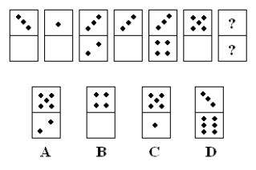

**Read the paragraph below and answer accordingly.**

Many consider World War I to have been the first modern war, a total war where the civilian populations were deliberately endangered as a direct tactic of war, which has continued in all subsequent wars. While civilians have always died in wars, World War I made civilian casualties accepted and commonplace, from, for example, aerial bombardment. All aspects of the societies fighting were affected by the conflict, often causing profound social change, even if the countries were not in the war zone.

**15. It is stated in the reading that World War I ----.**

A) caused a major depression in countries that were against killing civilians

B) introduced the killing of civilians as a method of warfare

C) is the bloodiest war in history

D) marked the end of the most peaceful period in modern history

E) was not the first war to be fought on a worldly scale

**16. It is pointed out in the passage that ----.**

A) the war's economic impact was felt sharply in countries that were close to the war zone

B) the aftermath of World War I brought more attempts to protect civilians in war

C) unlike all subsequent wars, World War I was worldwide

D) more civilians than soldiers were killed in World War I

E) the impact of the World War I was felt even by the countries which weren’t close to the war fronts

**17. We can understand from the passage that ----.**

A) very few countries had designed or built aircraft specifically for war functions before World War I

B) World War I was not the first war in which civilians died

C) many consider World War I the defining moment of modern life

D) the aerial bombardment of civilians was widely criticized

E) deaths in World War I usually resulted from mistake, accident, or being too close to a military target

“There are many times when someone suffering from either mental illness or depression may not even realize there is a problem. I have suffered from depression myself. I was completely unaware of what was wrong with me, my family doctor pointed it out to me, as I did not have any one else around me that recognized the symptoms. It was hard for me to accept at first, but after having the hard facts placed in front of my face and understanding that it may get worse, I had no choice but to get help. A lot of people who suffer from such problems tend to be more alone than anyone realizes. I suspect that anyone who was unaware of their condition would probably be shocked, as I was, to have someone confront them about it. A good friend would confront them anyway, and hopefully they would seek help.”

**18. It can be understood from the passage that ----.**

A) some doctors are unaware of their patients' problems

B) a lot of people have family doctors

C) mental illness is not a big problem today

D) people cannot easily realize their own mental illnesses

E) we have a lot of choices to become healthy

**19. Someone who is suffering from either mental illness or depression ----.**

A) should go to his family doctor

B) may give damage to other people

C) has to find his friends to talk about it

D) will one day realize everything if he wants

E) generally, isn't aware of the condition

**20. The author seems to be suggesting that ----.**

A) large families generally have a family doctor

B) we cannot be aware of how much these ill people suffer

C) the people who are suffering from mental illness should go to doctors

D) everybody can easily accept their illness

E) there are a lot of people in our society who are suffering from mental

illness